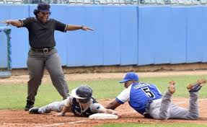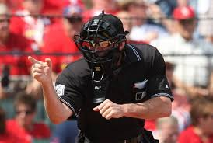
Umpires Needed
No Prior Experience Required
Training Sessions in March
Most likely via Zoom
Games in April & May
(Weekdays and Saturdays: Pay Rate = $25-$35/game)
7th/8th Graders and Older
Contact Mark Harris-ngsaumps@gmail.com or Text:847-530-5186 