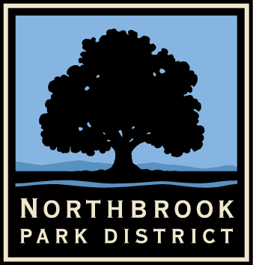
MEDIA RELEASE
Contact: Joan Scovic. 847-897-6129
(Phone numbers for media use only, not for publication)
545 Academy Drive, Northbrook, IL 60062
For Publication: July 6, 2021

Northbrook Park District’s Party on the Green Offers a Free Afternoon of Entertainment!
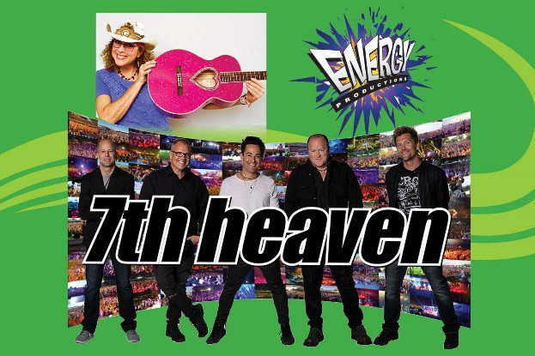
Northbrook Park District presents Party on the Green, a new community event on Saturday, July 24 from 1pm-4:30pm at Village Green Park, located at the corner of Shermer Road and Meadow Road in downtown Northbrook.
Musical Entertainment at Party on the Green will include Jeanie B!, Energy Productions, and 7th Heaven.
A variety of entertainment will take place on the stage in the ball field including musical fun for kids of all ages with Jeanie B! from 1pm-1:45pm, games and activities with the DJ from Energy Productions from 2pm-3pm and Chicagoland favorite 7th Heaven headlining the afternoon from 3pm-4:30pm. Bring blankets and chairs to enjoy the music and stop in at one of Northbrook’s amazing restaurants to pick up a picnic lunch or a sweet treat.

The talented team from Clowning Around will be in the park offering glitter tattoos, a photo booth, balloon animals and giant soccer darts. You can also stop by to play some lawn games!

Be sure to visit the sponsor area for additional activities, games, giveaways, and information. Party on the Green Gold Level Sponsors include Berkshire Hathaway Home Services Chicago, California Closets, ClubZ! In-Home Tutoring Services, Consumers Credit Union, First Bank of Highland Park, Noggin Builders, Northbrook Dairy Queen, Northbrook Living Magazine, Nothing Bundt Cakes Deerfield, and Russian School of Mathematics. In addition, stage decorations for the bands are being provided by Gold Level Sponsor Barbara’s Balloons.

There will also be a free prize drawing for over $750 in prizes donated by Culver’s Northbrook, Francesca’s North, Illinois Bone and Joint Institute, Lou Malnati’s Northbrook, Marcello’s, and Sarpino’s Northbrook along with Northbrook Park District items.

In case of inclement weather, an update will be made on the District’s Rainout Line system. To learn more and to sign up for notifications visit nbparks.org/facility-status.

The Mission of the Northbrook Park District is to enhance the community by providing outstanding services, parks and facilities through environmental, social and financial stewardship..

